IT RCSA Audit Documentation
Server Protection – BSI.IT.10.C19
Design Assessment, Walkthrough and Sample of One (BigFix action 00-126993 – CrowdStrike Windows sensor)
DESIGN RATING | SAMPLE | OBSERVATIONS
SATISFACTORY | BigFix 00-126993  PASS | 2

Control | BSI.IT.10.C19 – Server Protection (Key, Semi-Automated, In every operation)
Review period | 07/05/2025 – 07/04/2026 (evidence captured 11/03/2026)
Walkthrough | IT RCSA (Edward Morfa) met with Ian Rojo (control owner) and [Infrastructure / InfoSec participants – to be confirmed] on [walkthrough date - to be confirmed]
Sample of one | BigFix permanent action 00-126993 SOFTWARE_DEPLOYMENT_CROWDSTRIKE_WINDOWS_SENSOR – issued 11/19/2024, Open, 25 of 25 applicable computers completed
Evidence folder | CDA/C19_CDA_Evidence (E01 – E10). Start with BSI.IT.10.C19_E00_Evidence Index.xlsx. Answers to the CDA questions, including Q7, are in CDA/BSI.IT.10.C19 Server Protection - CDA Questions 2026.docx.

Control description
[BSI.IT.10.C19 Server Protection] In every operation and upon imaging of a server, Infrastructure Engineering installs Endpoint Protection on the server to mitigate the risk of any malicious software. Exceptions to disable malware protections on server are approved by the CISO (or delegate).

How to use this document
This is the CDA walkthrough document; it sits in the CDA folder, and every file it references is in CDA/C19_CDA_Evidence, named by E-number (for example C19_CDA_Evidence / E06). Files from the CPA folder were copied in (same MD5). The E00 Evidence Index lists every file with its MD5. Each result in Section 3 names its evidence and where to look. Section 4 lists every place the sample appears. Results read: Pass (green), Fail (red), Observation / Open (amber - not an exception).

Evidence References
Ref | Evidence | Used for
CDA E01 | Virus and Malware Protection Standard v6.0 (07/28/2026) | SUS.VMPS.4.2.3.2, 4.2.3.3, 4.2.3.5 (p.8); sec. 6; Appendix E
CDA E02 | Virus and Malware Protection Standard v5.2 (05/28/2025) | In force at start of period
CDA E03 | Linux CrowdStrike install procedure | Manual install steps
CDA E06 | BigFix CrowdStrike permanent action 11/03/2026 | Action 00-126993 (sample of one)
CDA E08 | CMDB extract 11/04/2026 (first) | 5 CIs, all created 04/2025 – superseded by E04
CDA E09 / E10 | CMDB extract – 294 Installed Windows / Linux servers (query 11/04/2026) and CMDB Population Analysis | 16 Linux servers built in the period; random sample of 5
CDA E07 | SEF exceptions 07/01/2025 – 07/04/2026 | Blank file

1. Design Effectiveness Summary
The control design is effective. Trigger: server build. Windows servers carry the CrowdStrike Falcon sensor in the image, and BigFix permanent action 00-126993 pushes the sensor to any domain machine where it is missing – it never expires, re-applies an unlimited number of times and retries up to 5 times (CDA E06). Linux servers get the sensor at build, installed by the Linux admin with InfoSec's settings (CDA E03). Criteria: EDR must run continuously on all servers and exceptions need CISO approval through SEF (CDA E01, SUS.VMPS.4.2.3.2–4.2.3.3, sec. 6).
Overall Rating: Satisfactory, with observations: (1) the Linux install note is not under document control (no owner, date or version); (2) the SEF export for the period is blank and needs confirmation.

2. WT Summary
IT RCSA met with Ian Rojo (control owner) and [Infrastructure / InfoSec participants – to be confirmed] on [walkthrough date - to be confirmed]. The owner confirmed the process is unchanged from the 06/06/2025 walkthrough.
- Windows: sensor in the gold image. BigFix action 00-126993 has member actions 00-126994 Servers (Miami Group), 00-126995 Servers (Virginia Group) and 00-126996 Workstations & Laptops. A machine without the sensor becomes relevant and gets it installed.
- Linux: InfoSec provides the CID and settings; the Linux admin installs the RPM, sets the CID, starts the sensor and confirms it in the console or with ps -e | grep falcon-sensor.
- Monitoring: InfoSec watches the CrowdStrike console; gaps go to Infrastructure through ServiceNow.
- Exceptions: an agent that can't be installed or must be disabled needs a SEF exception approved by the CISO (or delegate).
Sample of one: BigFix action 00-126993 was checked end to end. Results are in Section 3.
Based on the walkthrough, the control appears to be designed appropriately. The BigFix action was live for the whole period, covers both server groups and shows every applicable computer completed.

3. Sample of One – BigFix action 00-126993
Workpaper column | Value / conclusion | Evidence reference | Result
"installs Endpoint Protection on the server" – install method (A1) | BigFix baseline SOFTWARE_DEPLOYMENT_CROWDSTRIKE_WINDOWS_SENSOR (Master Action Site) | CDA E06, Source section | Pass
Covers servers (A1) | Member actions 00-126994 Servers (Miami Group), 00-126995 Servers (Virginia Group) | CDA E06, Member Actions box | Pass
Active for the whole period (A1) | Issued 11/19/2024 12:24:59 PM by MIAYPER; State Open on 11/03/2026 | CDA E06, Details / Actions list | Pass
"In every operation" – re-applies to new / missing (A2) | Never expires; re-applied as a policy an unlimited number of times; retried up to 5 times | CDA E06, Execution box | Pass
Execution result | 100.00% Completed – 25 of 25 applicable computers; 26 reported | CDA E06, Status box | Pass
In-period deployments | 07/02/2025 single action 1/1; 09/02/2025 SERVERS (MIAMI Group) 3/3 – both completed | CDA E06, Actions list | Pass
Exceptions approved by CISO | None needed; SEF export blank | CDA E07 | Pass
Linux servers built in the period | Full CMDB extract (294 Installed, query 11/04/2026) gives 16 Linux servers installed 07/05/2025 – 07/04/2026; random sample of 5 selected for the CPA (mia-dc-analytics, ashecofs, asht24webuat, mia-dc-mqtest, miaecowebtst); CrowdStrike evidence requested | CDA E09, E10 tabs C19 population, C19 sample selection | Open
CMDB population complete? | Installed date = record creation date; Class filter leaves out RHEL servers recorded under other classes (e.g. ashocp-xhktf-master-1 / worker-1) | CDA E08, E09, E10 | Observation
Conclusion: Sample BigFix action 00-126993 PASSED. The action was open for the whole period, covers both server groups, never expires and completed on all 25 applicable computers, in line with SUS.VMPS.4.2.3.3. The Linux side is an open item: the CMDB gives 16 Linux servers built in the period; a random sample of 5 has been selected for the CPA (CDA E10 tab C19 sample selection) and their CrowdStrike evidence requested.

4. Evidence Locator – where to find the sample
Ref | Evidence | What it shows
CDA E01 | Virus and Malware Protection Standard v6.0 – SUS.VMPS.4.2.3.2–4.2.3.5 (p.8), sec. 6 | Criteria
CDA E06 | BigFix CrowdStrike permanent action 11-03-2026 – Figure 1 | Status, members, behavior, details (Exhibit A1)
CDA E08 | CMDB extract 11-04-2026 – Page 1 rows 2–6 | 5 CIs created 04/2025 (superseded)
CDA E09 / E10 | Full CMDB extract; E05 tab C19 population | Random sample of 5 of the 16 Linux servers to test (CPA)
CDA E07 | SEF export | Blank
WP2 | WP2 BSI.IT.10.C19 Server Protection 2026.xlsm – Control Design Assessment tab (Q1 – Q7, comments) | Same results in workpaper form

Appendix A – Sample Evidence
Exhibit A1: BigFix console – action 00-126993 (CDA E06)
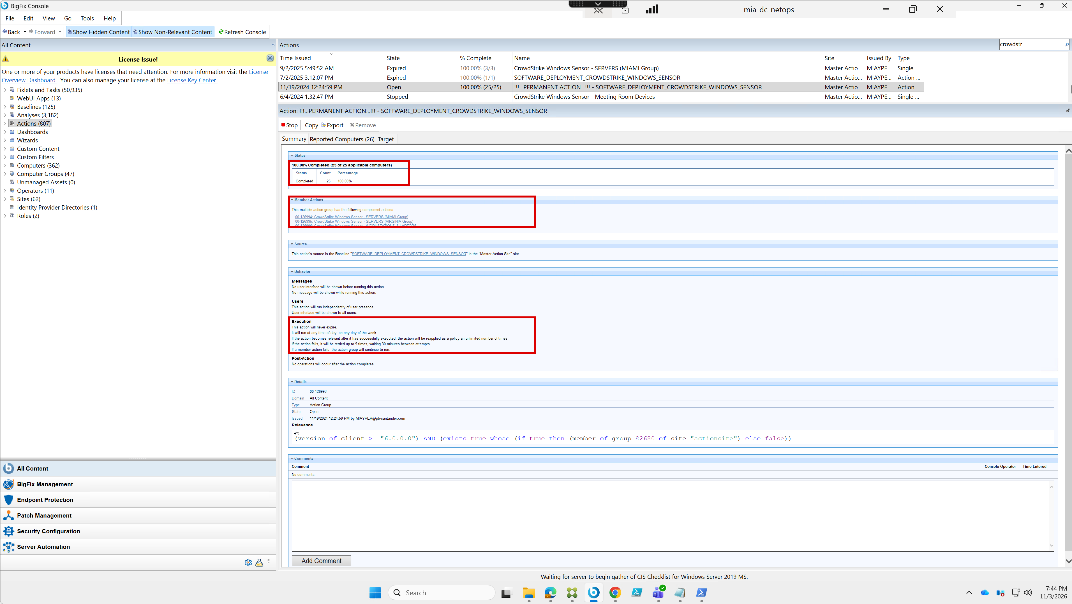
Source: CDA E06 – BigFix console on mia-dc-netops, captured 11/03/2026 7:44 PM by Roman Francisco. Red boxes: status (25 of 25), member actions, execution behavior.
Field | Value
Action | 00-126993 !!!...PERMANENT ACTION...!!! – SOFTWARE_DEPLOYMENT_CROWDSTRIKE_WINDOWS_SENSOR
Issued | 11/19/2024 12:24:59 PM by MIAYPER
State | Open
Status | 100.00% Completed (25 of 25 applicable computers); 26 reported
Members | 00-126994 Servers (Miami Group); 00-126995 Servers (Virginia Group); 00-126996 Workstations & Laptops
Behavior | Never expires; re-applied unlimited times when relevant; retried up to 5 times, 30 minutes apart
Other actions in list | 09/02/2025 CrowdStrike Windows Sensor – SERVERS (MIAMI Group) 3/3 Expired; 07/02/2025 SOFTWARE_DEPLOYMENT_CROWDSTRIKE_WINDOWS_SENSOR 1/1 Expired
Package: CDA folder (this document, CDA Questions 2026 and C19_CDA_Evidence E01 – E10), E00 index and WP2 2026 workbook. CPA testing and its evidence are kept separately in the CPA folder.

